Understanding of the World knowledge organiser - Year group Foundation Stage - term Advent 2
Area of learning |  | By the end of this term Your child will be able to….
Understanding of the world  - Comparing environments |  | - Describe their immediate environment using knowledge from observation, discussion, stories, non-fiction texts and maps  - Explain some similarities and differences between life in this country and life in other countries, drawing on knowledge from stories, non-fiction texts and (when appropriate) maps.
Coverage
This term we are going to be learning about our local environment and comparing it with different places around the world. We will be learning how to find places on a globe, recognise key features of different places and compare these with our own environment.
Key vocabulary | Key questions your child should be able to answer by the end of the unit |  | Books to support topic
- Location – a place or position  - Environment – the natural world in which we live in  - Globe- a model of the Earth  - Map- an area of land or sea shown as a drawing  - Features – something that makes the place special and different or the same  - Similarities and differences – things that are the same anf things that are different. | - Can I find Loughborough on a map?  - Can I recognise the features of where I live?  - Can I find a hot and cold place on a globe?  - Can I compare hot/cold locations with my local environment? |  | 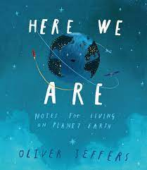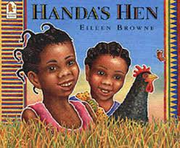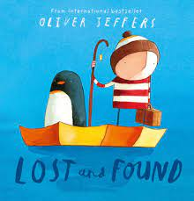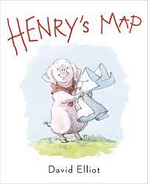
Key images about topic
