EYFS maths- Advent 2
This term we will be looking at greater depth the numbers 1,2,3,4 and 5. We will be counting accurately up to these numbers, writing them as numerals and recognising them as words, recognising one more and one less up to 5, how we make these numbers, number bonds to 5 and subtraction.
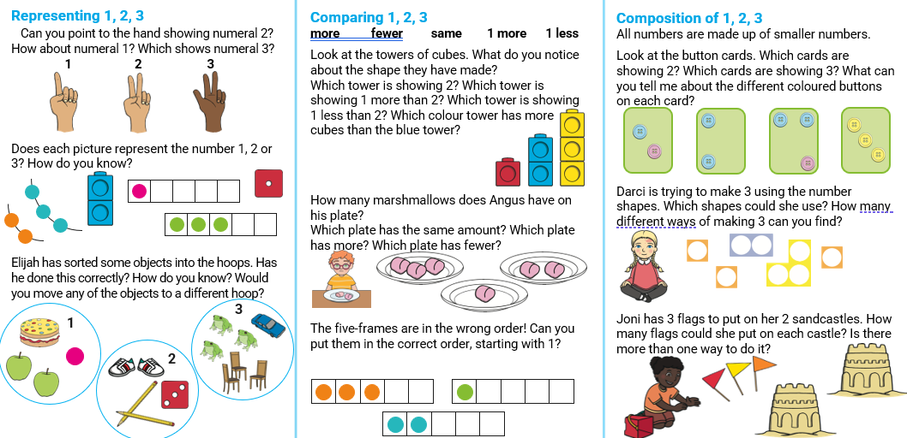

We will also be using Numberblocks to help support our learning – the episodes used will be sent home for you to enjoy together.
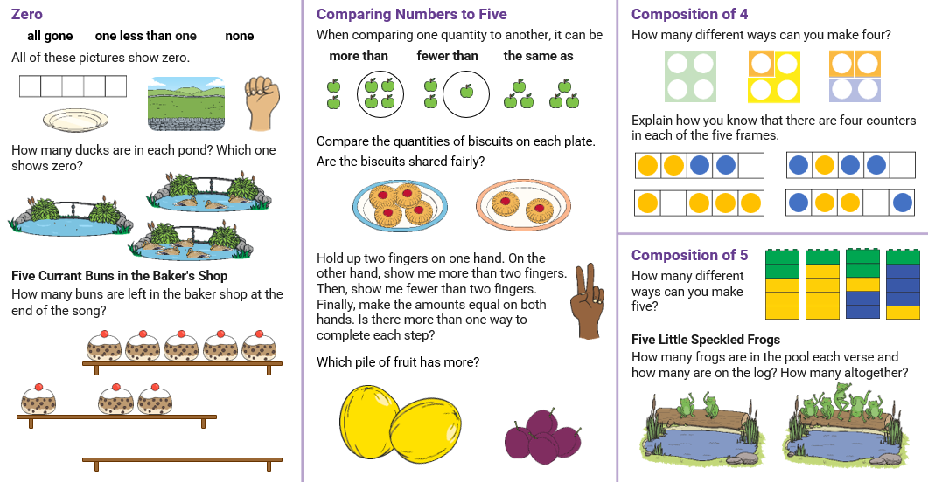
Books and songs to support learning
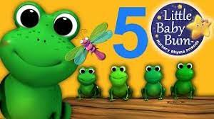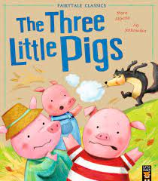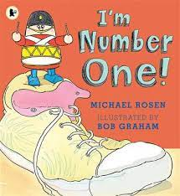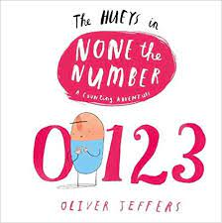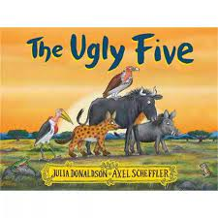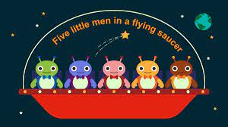
We will also be learning about the features of some 2D and 3D shapes.
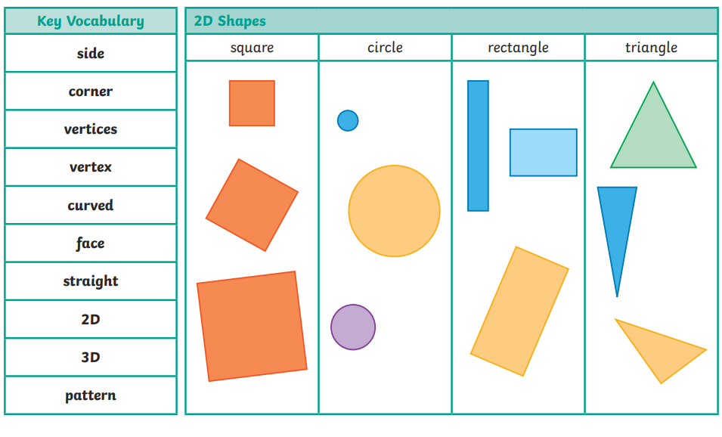
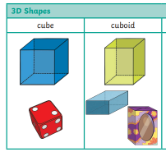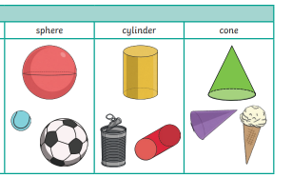
We will also be learning recognise times through days of the week, months of the year and what happens in a sequence of events.
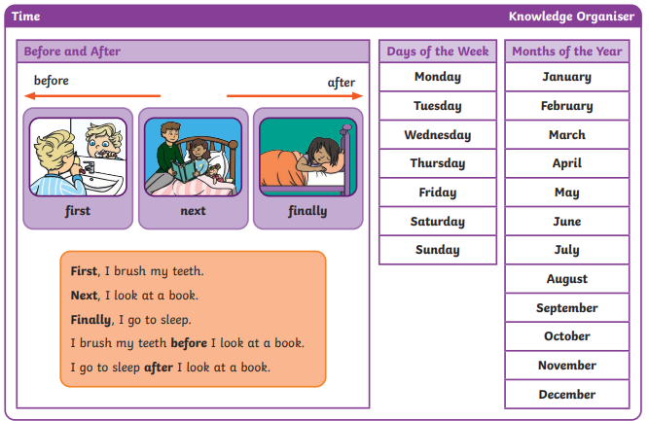
We will also be learning to recognise coins especially 1p, 2p and 5p and how we can make these coins.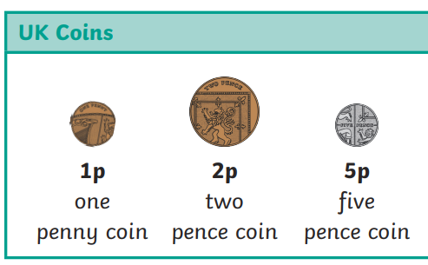 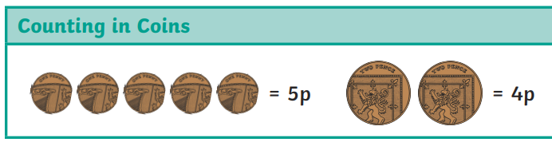
Books to support learning
