Sacred heart Expressive arts and design knowledge organiser
Year Group: Foundation Stage |  |  | Term: Advent 2
Coverage: This term we will be looking at paint and materials and how they can be used to create images. We will also be looking at an artist called Megan Coyle, who uses collage to create landscape pictures.
Area of learning – Expressive arts and design |  | By the end of this term Your child will be able to….
Creating with materials  - Explore, use and refine a variety of artistic effects to express ideas and feelings.  - ELG: Creating with materials: Safely use and explore a variety of materials, tools and techniques, experimenting with colour, design, texture, form and function.  - To create art in the style of an artist |  | - Explore how paint feels.  - Cut materials with more confidence.  - Understand what collage means  - Recognise a famous artist and some of their works.
Key vocabulary | Key images to support learning
- transient art – art that is not fixed or permanent  - collage  - fixed/permanent  - not fixed/temporary  - finger paints | Megan Coyle  American artist – present day  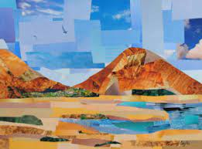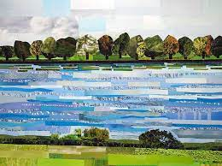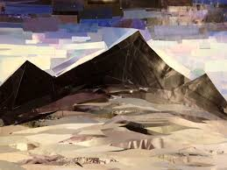
Key books to support learning
