Sacred heart Expressive Arts and design knowledge organiser
Year Group: Foundation Stage |  |  | Term: Advent 2
Area of learning -  Expressive arts and design |  | By the end of this term Your child will be able to….
Creating with materials  - Safely use and explore a variety of materials, tools and techniques, experimenting with design, form and function.  - Share creations, explaining the process they have used. |  | - Design their own model  - Evaluate their own product and those of others.  - Recognise different ways of joining materials  - Use scissors with more confidence
Coverage
This term we will be learning how to join materials using different techniques and create our own junk model.

Key vocabulary | Key questions your child should be able to answer by the end of the unit |  |  | Books to support topic
- Assemble – to fix parts together  - Design – to plan an idea  - Evaluate – to look closely at a product  - Product – object/image/something that has been made | - Can I evaluate mine and other people’s product?  - Can I join materials using the correct technique? |  |  | 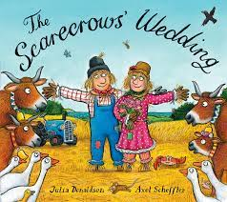
Key information about topic
