Year 3 Homework
In Year 3 you will receive a weekly homework sheet that consolidates the learning of that week. An example of this sheet is below. Weekly spellings will also be set following the whole school template. See example of template below. Within the term there will be at least one research style piece of homework. Children can also access IXL and Times Tables Rock Stars in addition to work that is set.
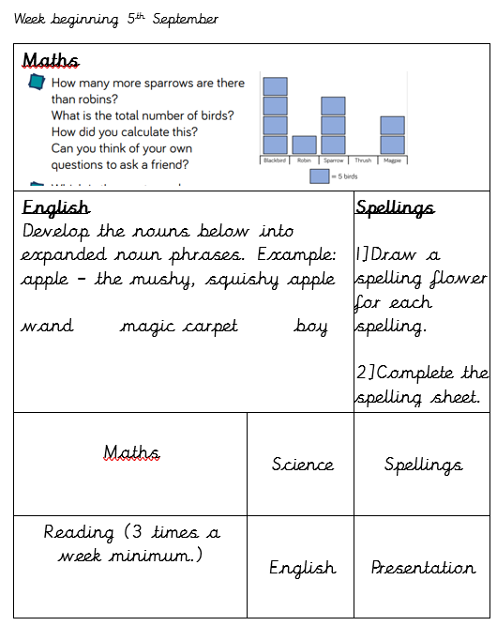
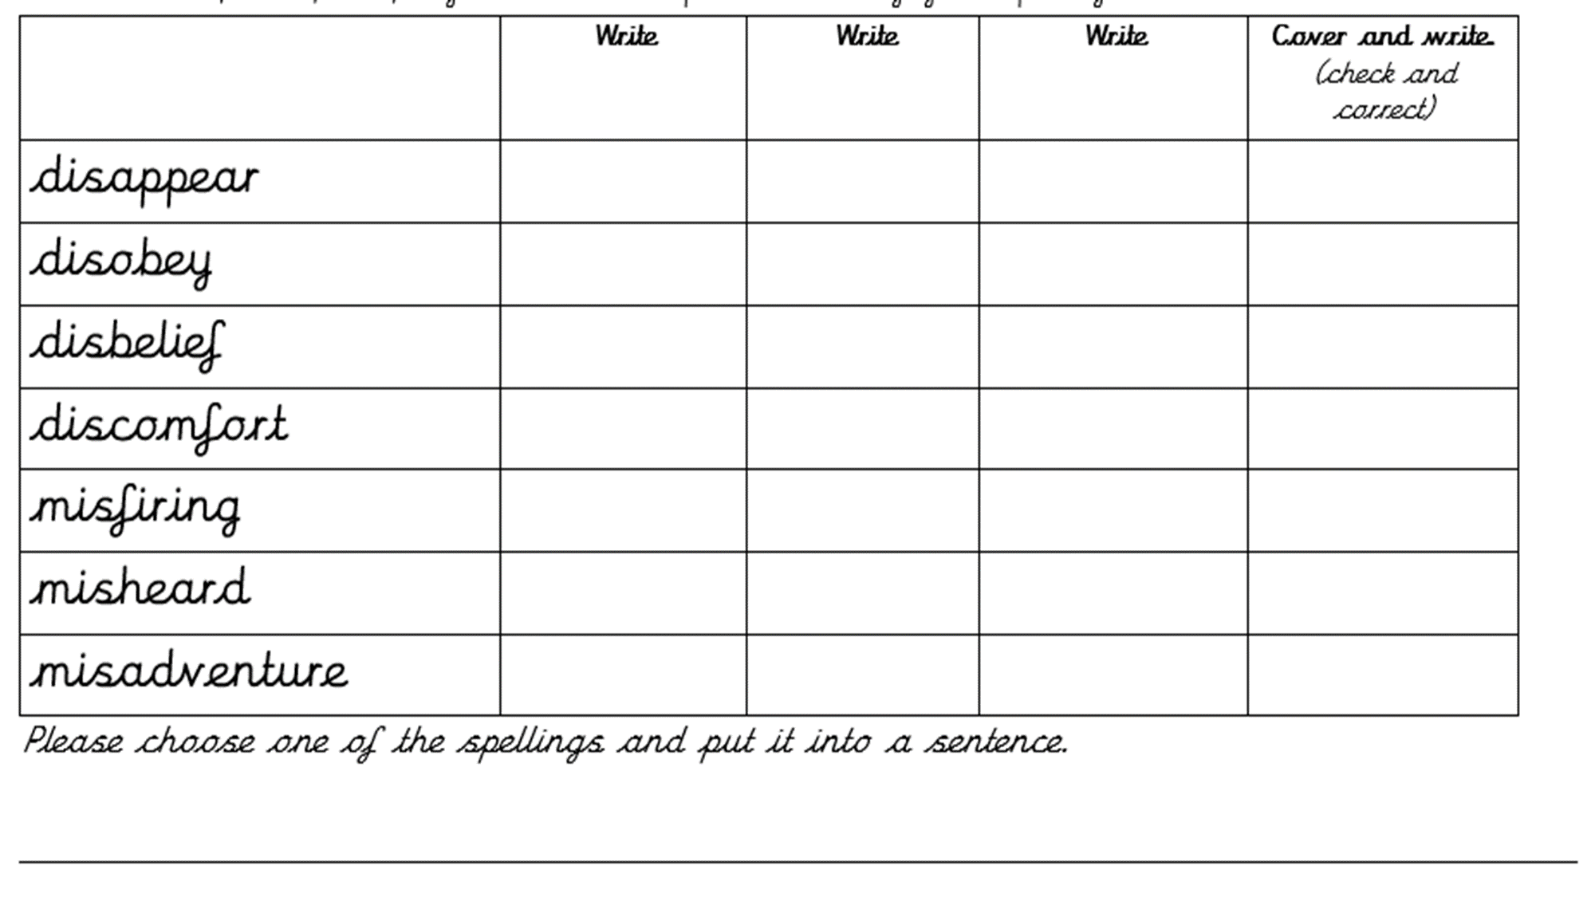
Homework should take approximately one and half hours a week. As parents, you are primary educators so do speak to me if you feel your child needs less or more work. Reading should always be priority in terms of work being completed at home.

