Big Question: What do plants need to grow?

**roots** – these anchor the plant into the ground and absorb water and nutrients from the soil

**stem** – holds the plant up and carries water and nutrients from the soil to the leaves

**germination** – when a seed starts to grow. leaves – make food for the plant using sunlight

**flowers** – make seeds to grow into new plants nutrients - are substances needed by living things to grow

**pollinators** – animals or insects which carry pollen between plants

**petal** – brightly coloured part of the flower that attracts insects

**seed dispersal** – a way of moving the seeds away from the parent plant

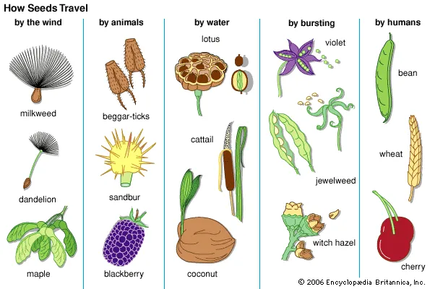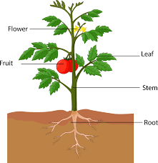

**Flashback Questions – Sticky Knowledge**

Describe how plants need water, light and a suitable temperature to grow and stay healthy. Describe how seeds and bulbs grow into mature plants. What is the difference between deciduous and evergreen trees? Describe weather associated with the seasons and how day length varies.

**Assessment Questions**

How does water move through a plant? Can I identify the different parts of plants? What different ways are seeds dispersed? What is pollination?