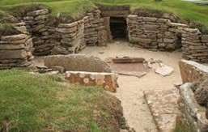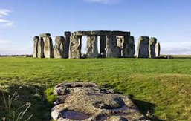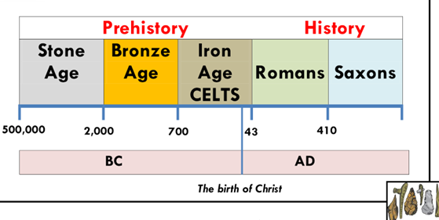

**Flashback Questions – Sticky Knowledge**

What is the difference between past and present? Which famous people do we know about from the past? What was their role in society? How did they change the past? How long ago was the Victorian era? Was this before or after your grandparents were alive?

**Assessment Questions**

What jobs to archaeologists do and why are they so valuable in helping us find out about history? How did the early Britons make shelters? What can you find out about the Stone, Bronze and Iron ages? What do we know about the life-styles of the Early Britons?

**Prehistoric:** The time in history between stone age and the first written records.

**Stone Age:** When the first humans began to live in Europe, they used stones as tools.

**Palaeolithic:** Early Stone Age people hunted with sharpened sticks. They used animal skins to make clothes and shelters.

**Mesolithic**: Middle Stone Age people dig flint out of the ground, using antlers as a pick. They make weapons to hunt, and a domestic wolf- which is the beginning of man’s relationship with dogs.

**Neolithic:** Around 6,500 years ago a change took place in the way Stone Age people lived: hunter-gatherers settled in one place and kept animals and grew crops.

**Skara Brae:** A well preserved Stone aged village in Orkney Scotland.

**Stonehenge:** The famous Stone Age stone circle in Wiltshire England.

**Flint:** A stone material for making stones and weapons.

**Iron:** a strong, hard magnetic silvery-grey metal.

**Bronze:** A mixture of the metals tin and copper.

**BC:** Any dates before the birth of Jesus Christ.

**AD:** Any dates after the birth of Jesus Christ.

Big Question: Who first lived in Britain?