Timeline
350 Saxons try to invade England but are fought off by the Romans
410 Roman rule in Britain ends
448-550 Jutes, Angles and Saxons invade and settle
450 Saxons settle in Kent
556 The 7 Kingdoms are created across England
597 St. Augustine bring Christianity to Britain and becomes the first Archbishop of Canterbury
617 Northumbria becomes the Supreme Kingdom
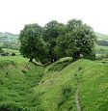
779 Mercia becomes the Supreme Kingdom and King Offa builds a Dyke on the Welsh border
793 Vikings raid Lindisfarne Monastery
794 onwards Viking raids
821 Wessex becomes Supreme Kingdom
855 Edmund the Martyr becomes East Anglian King
865 Great Viking army from Denmark invades
866 Vikings capture York (Jorvik) and settle
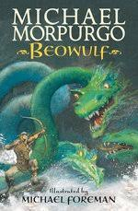
871 King Ethelred defeats a Viking army at the battle of Ashdown
876 Vikings settle permanently in England
886 King Alfred the Great defeats the Vikings but allows them to settle in the Kingdoms of York and East Anglia. Known as Danelaw and ruled by King Guthrum
901-937 Danelaw conquered by the English
954 Eric Bloodaxe, the last Viking King of Jorvik is thrown out
980 Viking raids on England
994 Vikings lead an unsuccessful siege of London and ransack South East of England
1014 King Canute of Denmark captures England
1042 Edward the Confessor (Saxon) becomes King
1066 Norman invasion. William the Conqueror becomes first Norman King
Saxon Vocabulary

Thatched house - wooden walls with roof of straw/reeds
Eye holes – holes in houses’ walls that you could look out of instead of windows
Lyre – musical stringed instrument like small harp
Runes – letters used to write words
Supreme Kingdom – most important Kingdom / territory
Burial ground – place where bodies are buried
Jewellery – personal decorations
Brooch – ornament used to fasten materials
Pottery – items made from fired clay
Bronze Helmet – metal protection for head
Sword – weapon with blade and hilt to hold
Shield – wooden/metallic, carried for protection

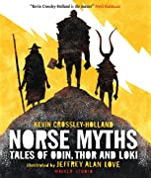
Class novels:
Beowulf by Michael Morpurgo, Norse Myths: Tales of Odin, Thor and Loki by Kevin Crossley-Holland
Recommended books:
Viking Boy and Anglo-Saxon Boy (Tony Bradman), How to train your dragon series (Cressida Cowell), The Time-Travelling Cat and the Viking Terror (Julia Jarman), Riddle of the Runes (Janina Ramirez)

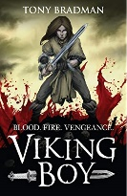
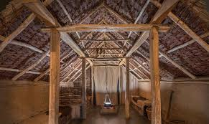
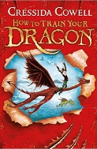
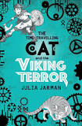
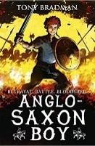
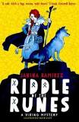

Viking Vocabulary

Jorvik – Viking name for York
Danelaw – part of England ruled by Vikings
Trade – exchanging of goods
Merchant – a person involved in trading goods
Longboat – type of large rowing boat
Longhouse – wooden one-room dwelling
Horn cup – drinking cups made of animal horn
Spear – pole with a sharpened (metal) end
Axe – weapon or tool, sharpened metal head
Archer – person who fires arrows from a bow

Find out more about the Saxons & Vikings?
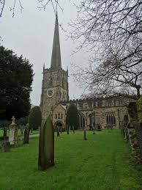
Visit:
St. Wystan’s Church in Repton has an Anglo-Saxon crypt which is the burial place for two Anglo Saxon Kings of Mercia.
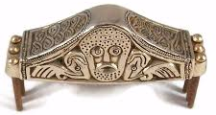
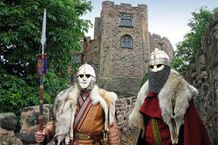
Tamworth Castle. Birmingham Museum & Art Gallery or the Potteries Museum & Art Gallery to see some of the Staffordshire Hoard.
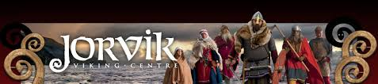
Jorvik Viking museum in York.

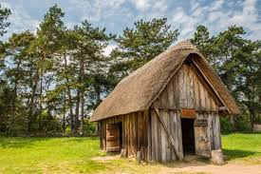
The Museum of London includes a Saxon house. Sutton Hoo treasure in British Museum, London.

West Stow Anglo-Saxon village in Suffolk.

