**Geography Knowledge Organiser – Years 5 & 6**

**Vocabulary**

**Settler** - a person who moves with a group of others to live in a new country or area

**Settlement** - a place where people establish a community

**Eye holes** – holes in the houses that you could look out of instead of windows

**Invader** – a person or group that invades a country or place

**Raider** – a person who attacks an enemy in order to steal something

**Pagan** – a person holding religious beliefs other than those of the main world religions

**Monastery** – where monks live

**Offa’s Dyke** – a large linear earthwork that roughly follows the current border between England and Wales

**Jutes** – a member of a Germanic people that joined the Angles and Saxons in invading Britain in the 5th century, mainly settling in Kent

**Angles** – A member of a Germanic people that invaded Britain. They settled in East Anglia

**Saxons** – As Angles – they settled in Essex, Sussex, Middlesex and Wessex

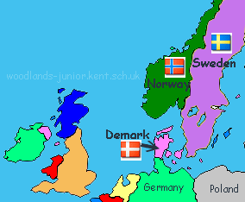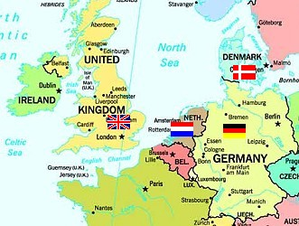

Many place names give us clues about Anglo-Saxon and Viking Britain.

**Anglo-Saxon:**

*Burh –* meaning ‘town’ as in Peter**borough** and Lough**borough**

*Ford –* meaning ‘shallow river crossing’ as in Stam**ford**

*Ham –* meaning ‘village’ as in Birming**ham**

**Viking**

*-by –* meaning ‘town’ as in Derby (town where there are deer)

*-toft –* places ending in -toft refer to the site of houses or a plot of land.

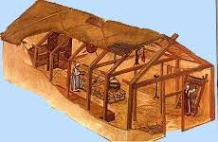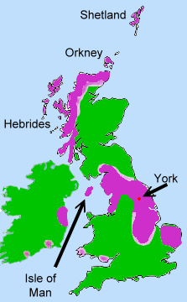

Where did they live?

Anglo-Saxons and Vikings were farmers and so lived in areas where there was farm land. They lived in thatched houses in villages around Britain. They grew and harvested their own food to eat.

Places the Vikings invaded and settled included York (they called it Jorvik and it was the second biggest town in England after London at the time!)

The Vikings were from Denmark, Norway and Sweden and were also farmers and fishermen who traded, raided and settled in parts of England and Scotland. All of the places that the Anglo-Saxons and Vikings invaded were easily accessible by sea or rivers as they sailed on large boats.

The Anglo-Saxons (made up of the Jutes, Angles and Saxons) were fierce farmers who came from Germany, Denmark and the Netherlands. They settled in England mainly because England had better land for growing crops. They sailed on large boats and invaded many parts of England.

