Key Vocabulary:
Loving
Y6 Topic 1
Scripture:
Isaiah 40: 1-5, 9-11, 28-31
Psalms 23 and 136
Luke 15: 11-32
Matthew 5: 1-12, 44-48
John 15: 9-14
Ephesians 4: 26, 31-32
Titus: 4-8
unconditional – without special exceptions
forgiveness – the act of excusing a mistake or an offense
mercy – kind and forgiving treatment of someone
prodigal – someone who wastes money carelessly
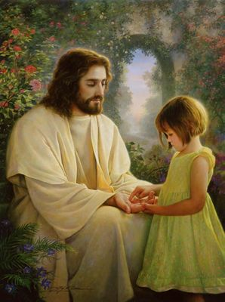
parable – a short story told by Jesus to tell a religious message
Big Question:
Do you have to earn love?
Other questions
Does love last forever or does it have limits?
How can I love people I don’t like?
How do you know you are loved?
Does a parent always love their children?
Bishop’s Crozier
Hymns:
Oh God you search me and you know me
The Lord is my Shepherd
I feel my Saviour’s Love by Greg Olsen

Sacrament: Baptism

Key Vocabulary:
Scripture:
Matthew 4: 19-22
Matthew 6: 19-21
Matthew 9: 9
Mark 1: 9-11, 16-20
Mark 2:14
Mark 16:15
Luke 5: 26-27
John 1: 35-41
Genesis 12:1-4
Vocation & CommitmentY6 Topic 2
commitment – a promise to do or give something
dedicated – to give all your attention and effort to a cause
vocation – a strong impulse or calling to follow a career or activity
Ordination – the process (Sacrament) which means someone becomes a Priest
anointing – to put Holy Oil on a part of the body
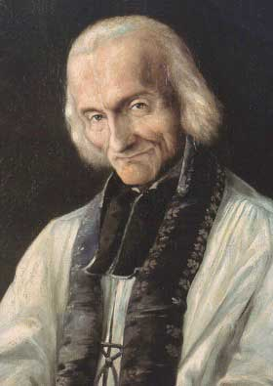
religious life – is a particular way to live out a Christian vocation
Sacraments:
Ordination, Baptism
Confirmation
service – the action of helping or doing work for someone
Hymns:
Follow me
Go out to the world
Here I am Lord
celibacy – the choice not to marry
vows – a solemn promise
Big Question:
What is commitment in life?
Other questions
Why are some people so dedicated to the service of others?
How does your priest help you?
What qualities does your priest have? Do you have any of these qualities?

Saint John Vianney – Patron of Parish Priests

Scripture:
John 1: 14-18
Mark 1: 1-5
Isaiah 35: 1-6, 9, 10
Isaiah 62: 11-12
1 Corinthians 1: 8-9
1 Corinthians 16: 13-14, 22
Key Vocabulary:
ExpectationsY6 Topic 3
expectation – a strong belief that something will happen
certainty – total belief that something is true
Advent – means ‘coming’: season including the four Sundays up to Christmas
Sacrament:
Eucharist
Christmas – Christian festival celebrating Christ’s birth on the 25th December
Emmanuel – name for the Messiah; Hebrew name meaning ‘God with us’
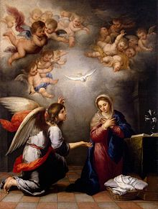
Annunciation – the announcement of Angel Gabriel that Mary would be Jesus’ mother
Angelus – a devotional prayer celebrating Jesus’ incarnation
incarnation – a person who is the human form of a God or a God-like quality
Other questions
Big Question:
Should we have expectations in life?
What is the difference between I wish for and I expect?
Why is it good to have high expectations of yourself and others?
What is the role of patience in expectations?

Prayers:
Angelus
Hymns:
Maranatha
O Come, O Come Emmanuel
Wait for the Lord (Taize)
Peace
Advent Wreath: Hope, Love, Joy (pink), Peace
The Annunciation by Murillo

